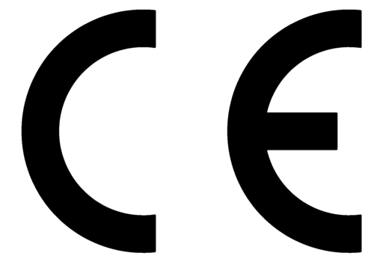
EC Declaration of Conformity

This declaration of conformity is issued under the sole responsibility of the manufacturer
The undersigned
INTER SALES A/S
Omega 5A, Soeften, DK-8382 Hinnerup, Denmark
certifies that the design and manufacturing of this Notebook
Product brand name: DENVER
Product model no.: NBW-14115BE
And imported into EU after 11th June 2017
conforms to the following directives and regulations/standards:
RED Directive 2014/53/EU - Health (Article 3.1a)

And standard:
EN 50566:2017, EN 62479:2010
[IEC 62479:2010], EN 62209-2:2010+A1:2019[IEC 62209-2:2010/AMD1:2019]

RED Directive 2014/53/EU – Safety Article 3.1 (a)

And standard:
EN 62368-1:2014+A11:2017

RED Directive 2014/53/EU – EMC Article 3.1 (b)

And standards:
ESTI EN 301 489-1 V2.2.3 (2019-11), DraftETSI EN 301 489-17 V3.2.2(2019-12)
EN 55032:2015/AC:2016, EN55035:2017, EN61000-3-3: 2013

RED Directive 2014/53/EU-RF (Article 3.2)

And standard:
ETSI EN 300 328 V2.2.2(2019-07)

and therefore, complies with the essential requirements of the EU Directives.

Signature: _________________________
Full name: Jakob Teichmann
Position: Purchasing manager
Company: Inter Sales A/S
Date: 12th October 2020

